Strategy Deck

Full PACK
Fixed Income Systematic Credit Derivative Investment Strategy

Summary:

I have developed a quantitative, systematic synthetic credit strategy that identifies and exploits inefficiencies and dislocations across the CDS Index and CDS Tranche universe (with single name CDS integration capabilities). I’ve built from scratch and tested the proprietary code that data extracts, quantitatively analyses and portfolio manages the strategy I propose to implement with full autonomy. The strategy has been back tested rigorously through worst possible cases and still delivers exceptional returns. This strategy captures and offers alpha in an underpenetrated corner of fixed income with quant and cash discipline, risk conscious framework and real-world execution pragmatism

Key Strategy Overview:
Investment products: CDS Indices, CDS Tranches (single name CDS for hedging/discretion)
Strategy: Scaling up a portfolio of beta adjusted buy/sell protection pairs, closing trades on pairs on exceptional returns
Goal: No/low cash usage and minimal margin requirements while maximising return-to-risk in a beta/correlation neutral framework that beats out right long risk in CDS Index and CDS Tranche products
Framework: Quantitative/Systematic backbone that adopts a z-score statistical engine and algorithmic signalling framework
Coverage: Developed markets; US (CDX), Europe (iTraxx) but not limited to it
Returns: Average log returns >100% (vs cash usage, with received cash capped at 100%)
Risks: Default losses accounted for. Equity tranche currently excluded. Other risks are treated and mitigated. Drawdowns are temporary in shocks and not realised losses

Strategy expansion: Possibility to L/S single name CDS or put on negative basis trades (carry and cash receiving)

Strategy Edge:
- Capital efficiency through long/short structures: Upfront payments and risk on long/short legs offset each other, minimizing net cash usage. Short-risk positions absorb margin needs, significantly reducing drag on capital
- Alpha through systematic trade discovery: A quantitative, signal-driven framework enables consistent trade identification, particularly for adding weight on positions that do not require immediate execution. Trades are beta-/duration-adjusted, and signals are calibrated to identify opportunities that generate positive returns net of costs, negative carry, defaults, and other structural frictions (as detailed later in this document)
- Portfolio hedging and thematic expression
The strategy allows for dynamic hedging of portfolio-level risks, including tail risks and risk baskets. It also enables discretionary views across regions, sectors, asset classes, FX exposures, or single-name issuers
- Portfolio construction flexibility
The framework supports portfolio construction based on key attributes such as carry, cash usage, CR01, and net exposure by product or issuer. Additional layers can be added to manage mark-to-market volatility and enhance return potential
- Predictable risk-reward profile
CDS instruments offer fixed maturities and predictable cash flows. The strategy can be programmed to optimize net carry to maturity against default risk and expected loss, ensuring a positive return profile. Cash usage is known and controlled
- Scalable and underutilized opportunity
Systematic macro CDS trading is underexploited, particularly at the scale and sustainability proposed in this strategy. Market dislocations persist, and major dealers (Citi, JPM, MS, BNP, DB, BofA etc) provide ample liquidity and depth. These factors are embedded into the model’s design and execution logic. The credit derivatives market continues to grow, offering increasing opportunity

Drawbacks, while not detrimental to long-term profitability, the following factors should be considered:
- Higher returns from only long risk trades, but with trade-offs
Selling protection outright (i.e., taking long credit risk) can generate 50–100% higher returns due to elevated carry. However, when traded spreads are below the running coupon, upfront costs rise significantly. CR01 exposure increases, leading to large mark-to-market swings (though not realized losses). Default risk is also higher, and collateral requirements can be substantial, adding operational complexity which my strategy mitigates
- Strategy Complexity and Data Requirements
The strategy requires robust data infrastructure and reliable service providers but are readily available and periodic. The model is designed to generate profitable signals even when trades are held to maturity or when exit targets are missed — for example, through long-risk non-equity tranches paired with net carry, or trades where default costs are more than offset by carry

Core Strategy Methodology:
CDS Indices/CDS Index Tranches:

Trade Structures: Buy/Sell Protection beta adjusted pairs between: Index vs Index, Index vs Tranche and Tranche vs Tranche

Base Screening: Quantitatively analyse and screen dislocations between all tradeable products. Finding viable mean reversions after beta adjusting, incorporating multiple factors, overrides, considerations, momentums and so forth in my model but not limited to it

Signals and Factors:
- Core Engine: Utilizes z-score analysis to detect statistically significant dislocations between historically regressed (beta-adjusted) pairs within the index and tranche universe. Checking the CR01s and direction exceed the required thresholds (FX conversions, transaction costs, liquidity adjusted absolute returns, total returns)
- Algorithmic Signalling: Algorithmically score and rank viable pair trades on multiple input factors: target spread/returns, net carry and rolldown analysis over time periods, basis/net asset value, realised and expected notional default probabilities, subordination and direction analysis, CDS constituent breakdowns etc
- Discretionary Views: Incorporation through momentum driven inputs given to develop strength of the target spreads (single name CDS are assigned views that generate momentum scores, so absolute momentum spreads which in turn recomputes the new target spread return)

Adjustments:
- Historic data adjustments: Adjustments are made to exclude anomalous periods (e.g., COVID-19, European gas crisis) to avoid skewed signals. Ensures that historical relationships reflect normalised market behaviour
- Live pricing and calculated deltas are used to reassess transaction costs and bid-ask spreads in real time. Ensures that trades remain viable post-market moves
- Incorporates maximum liquidity between the pairs given the current market climate and banks abilities and offerings. Finding the combination that generates the greatest return
- Beta taken by historical regression where the generic latest series at the time is taken before the actual CDS product in question is created/live as the new tenor
- Z score validation by taking 2 periods of lookback. From the initial start date period and then an alternative look back from trade date (6 months). Any longer, we expect relationships have changed for the good thereafter
- All data is FX Adjusted

Detailed Risk Coverage and Considerations:
Risk Category | Nature of Risk | My Risk Treatment & Resolutions
Correlation Sensitivity | Changes in implied/systemic correlation | Given the correlation pricing smile in tranches, this strategy/analysis excludes equity tranches, where correlations are weak and idiosyncratic risk dominates  Junior mezzanine to super senior have a positive trend between correlated underlying to tranche pricing. By nature of this strategy, with the core engine leveraging z-score analysis on beta adjusted pairs; trade opportunities are identified from these dislocations to pricing where correlation may not have adjusted pricing retrospectively in the pair
Spread Risk & Volatility | Spreads can reprice violently in stressed markets | The strategy utilizes historical data across multiple series, including prior vintages of the same product, to capture a range of market regimes and volatility episodes. Long/short pairs are constructed with similar durations and are beta adjusted, reducing exposure to outright credit spread moves and minimizing directional mark-to-market impact compared to a long-only position. Furthermore, the use of live reference index pricing and pre-calibrated tranche deltas enables real-time valuation of tranche exposures, supporting dynamic risk management and efficient execution
Dispersion/ Net Asset Value Adjustments | Tranche/Index pricing relative to the underlying CDS | The basis or net asset value (NAV) spread is incorporated into the directional positioning of each leg within the pair trade. This basis is then evaluated relative to the expected spread pickup, contributing to the overall strength and conviction of the trading signal
Default/Recovery Risk | Unexpected cluster defaults or lower recoveries | A custom recovery rate, default count and loss ranking can be assigned to each underlying ticker or index, which flows through into calculations of net basis(tranches), CDS hedge sizing, and expected notional default losses. This also informs the required net carry return necessary to offset projected defaults at the index and tranche level
Liquidity Risk | Bid-ask wider or notional reduced in tranches and off-the-run products | A liquidity analysis framework is implemented to assess the adjusted bid-ask spread and determine the maximum executable trade size per clip for each product. These calculations are based on current on-the-run liquidity metrics, including available notional and prevailing bid-ask levels across product sets such as CDX IG and iTraxx Main 5Y and so forth
Hedging Complexity | Imperfect hedging via index/potential basis risk | All pair trades are beta-adjusted to normalize risk exposure. The strategy generates a net single-name CDS exposure profile across the portfolio, enabling the identification and ranking of likely default candidates. These names can then be selectively hedged or used to enhance alpha generation.  Trades are initiated only when the expected total return meaningfully exceeds the modelled probability of default, serving both as a precautionary filter and a reinforcement of signal strength
Systemic Risk Exposure | PnL volatility since beta breaks and pairs have differing durations | Equity tranches are excluded from the strategy due to their high idiosyncratic risk and limited correlation reliability. Instead, long-risk index positions are selectively included when the expected carry exceeds a predefined loss threshold.  Given the transparent cash flow structure of CDS contracts, unrealized P&L tends to mean-revert over time. As a result, trades that deliver positive carry through to maturity are assigned stronger signals, serving as a built-in risk cushion and return anchor
Model Risk | Systematic processing to find and score pair trades | The strategy employs a rigorous and modular quantitative framework, designed to capture a wide range of potential outcomes for each pair trade. All models and assumptions are continuously refined, ensuring adaptability to evolving market conditions and the incorporation of new insights over time.  Extensive back testing taking the worst-case scenarios; shows profit realisation upon reaching certain thresholds (closing trades) as well as growing a portfolio on the more ‘optimum’ trades to hold to maturity to deliver very strong cumulative returns
Margin Requirements | Initial Margin and Variable Margin needs | A margin requirement calculation is implemented in a more enforced or needed way, with net upfronts to find total cash deployment needs. Initial margin is calculated looking at the risk spread (traded spread) x CR01, with a discount factor for IG over HY. And the variable margin is the running PnL that’s charged daily

Other Strategies (possibility to branch out):

Single Name CDS:
#2 Trade Structures: Long Short + Beta/Duration Adjusted: Single Name CDS vs Single Name CDS

Base Screening: Based on quantitatively screening dislocations/mean reversions pairs with the target spread calculated after the transaction costs, momentums and other factors are accounted for
- The ability to take discretionary views of an issuer vs another issuer based on the idiosyncratic nature. Whether its views on regions, sectors or company specific
- The ability to hedge single name net exposures for macro index/tranche pair trades as mentioned above as and when the pair trade fits

Signals and Factors:
- Momentum Input Driven: assign regions/sectors/ratings/tickers a momentum score then compute the momentum spread move based on RV in adjusting how much higher or lower the target spread should be against the mean reversion spread pick up
- Metrics computed include: net carry, net carry+roll down, transaction costs etc

Adjustments:
- Adjusting spreads to historic CDS relative to the ratings in the past against the rating now (spreads go tighter, as a company improves, and ratings increase. So this CDS should not revert to its historic mean)
Risks:
- Highly idiosyncratic. Possibility an individual name goes against you. Usually, CDS are good to maturity unless there are default risks. The default losses will be a lot significant versus the net carry return picked up

Credit Cash Bonds vs CDS (not a priority):

#3 Trade Structures: Positive/Negative Basis Trades between Bonds and CDS

Base Screening: Where possible, source positive basis trades (Sell CDS, Sell Bond) across all tenors (1Yr, 2Yr,3Yr,5Yr,10Yr) such that there's negative cash usage (subject to repo)
- Ability to raise cash by selling CDS and shorting the bonds without net notional default risk

Signals and Factors:
- Bond-CDS screener developed across the entire bond and CDS universe to find all possible candidates. Historic basis

CDS Indices/CDS Index Tranches Strategy:

Quantitative Process – Summary Flow:

Quantitative Process – Step by Step

  - Parameter Inputs (relevance explained in the next steps)

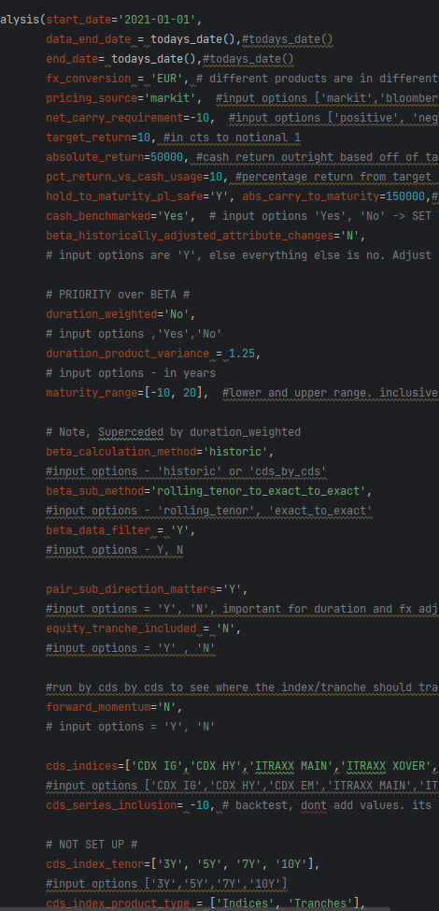
Start date/Data end date/End date: Time horizon to run the regression z score analysis from. And as of a particular date

FX Conversion: Conversion of data into one currency (thresholds spreads, CR01s, transaction costs, PnL)

Net carry requirement: Minimum tradable net carry requirement in bps once the pairs have been beta adjusted

Target return: Minimum target return in cts of a pair required
Absolute return: Minimum absolute target return required in FX converted currency

Hold to maturity safe: Total PnL for both legs in the pair return positive when held to maturity factoring expected default

Absolute carry to maturity: Minimum absolute return of the pair till maturity required post expected defaults

Cash benchmarked: The hurdle rate received/paid for cash used

Beta historically adjusted attribute changes: When assigning beta by single name CDS level, the current properties/ratings/attributes now will be different fundamentally than historically. Historical data is adjusted by a ratio based off the current ticker’s attributes. (Ratings are key coupled with a rating lag adjustment. Where a company’s rating change is priced in a few months before the announcement)

Duration weighted: Scaling the notional legs of the trade to make net CR01 risk equal to 0. Set to No, as beta adjustment is more important given the mutually exclusive relationship

Duration product variance: Difference in years to maturity of the pairs. Set to <1yr given beta prioritized over duration mismatch

Maturity range: Range of years to maturities required

Beta calculation method/Sub method/Data filter: Set to Historic (vs CDS level). ‘Sub method’ set to rolling tenor to exact, which takes the same tenor of the generic product historically until the actual product becomes live for historic regression/beta. Beta ‘Data Filter’ excludes certain dates for certain regions (ie EU gas crisis/Ukraine war)

Pair sub direction matters: Given mismatches in maturities, the CR01s don’t cancel out after beta adjustment. Trades are selected where the direction of the long shorts are in the right direction and profitable

Forward momentum: Assign and incorporate the scores to countries, sectors and tickers of CDS that make up the index and tranches for discretionary views and momentum spreads. Those that work in line with the direction signal provide a stronger signal and target return

  - Data Collection, Cleaning and Adjustments:

Produce and Extract Data:
      - Manual Inputs (entering in excel, assign momentum scores -5 to 5 for regions, sectors, tickers etc. Input deltas for each tranche) (Ticker Score: combination of my views and recommendations from CreditSights)
      - Historic Index/Tranche Quotes (from SQL via Markit)
      - CDS Constituents for Index/Tranches (from SQL via Markit)
      - Defaulted CDS (from SQL. Data manually inputted based off official auction results(https://www.creditfixings.com/CreditEventAuctions/fixings.jsp)
      - Historic CDS Quotes (from SQL via Bloomberg snaps
      - Interest Rate Swap Curves (from SQL, currently uses T-1)
      - Live Index Quotes (static, when script is run)
      - Live Tranche Quotes (static, when script is run. Uses index quotes and tranche deltas to compute levels)
      - Live CDS Quotes (further to enhance, make live. Uses T-1 in this quantitative script. CDS vs CDS its live)

Adjust and Assign Data:

- Beta Data Filter: neutralize historical data by the additional beta factor at the time

- Beta historically adjusted vs CDS attributes
  - Assigns rating change days before actual rating change to historic data. Then compares rating from now vs history relatively using a key. (rating_lag_adjustor_days = 60)
  - (further to enhance – for other attributes like sectors, regions etc)

- Generate CDS momentum (score -5 to 5) and momentum spreads
  - Firstly, generate spread ranges table. The average spread on each rating for each [sector, seniority, region, tenor] data set
  - Secondly, for each CDS using its rating and momentum score; find the likely momentum spread jump from the spread ranges table. (-5 = downgrade 100%, 5=upgrade 100%). If CDS are rated BBB and momentum score is 3 and the average spread(based on similar attributes) jump to BBB+ is -10bps. Then the momentum spread is 6bps tightening

  - Generate Index/Tranche Properties:

      - Calculate upfront amounts/cash usage
      - Cost of capital: impact from cash paid or received at risk free rate
      - Calculate the transaction cost/bid-ask
      - Calculate maximum liquid notional size in one clip (maximum liquid notional (current on the run 5yr) vs age of the series then factored by index/tranche percentage)
      - Calculate spread ranges (min, max, percentile of current) based off historical spreads of the same product despite series/tenor. The years to maturity are +/- 3 months of products years to maturity at the time
      - Calculate Rolldown + Carry. Set to Same Series over the Different Series curve method. The different series method orders the same product despite series and tenor from lowest to highest to maturity for rolldown+carry calculation. RC signal function of rc_risk(current spread) and rc_rtn(cash usage)
      - Calculate realized losses and default count (for tranches using CDS defaults, recovery rates, CDS constituent weights)
      - Calculate Basis/NAV and basis list (for tranches, the CDS are ranked, highest to lowest spread. Then to find all the CDS involved in the attachment and detachment; look to see the CDS weight, the non-recovery rate and work out the cumulative losses)
      - Calculate index/tranche momentum and momentum spread based on the CDS constituents
      - Calculate net carry to maturity (with or without expected defaults). Then calculate return against cash usage

Simplified Tab (the essentials):
Quoted in basis points to any notional put one. Returns are shown as outright percentages (10 = 10%)
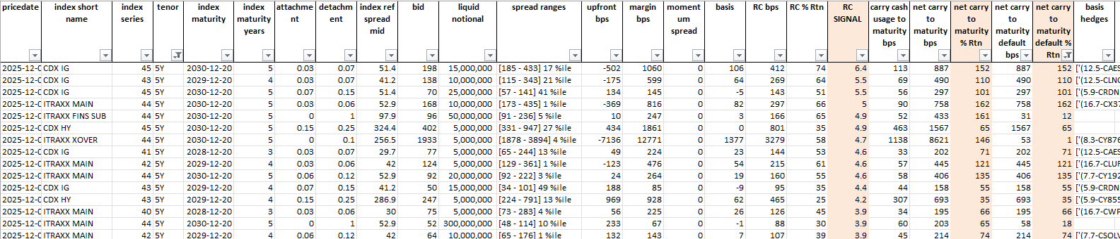
Full Data Tab:
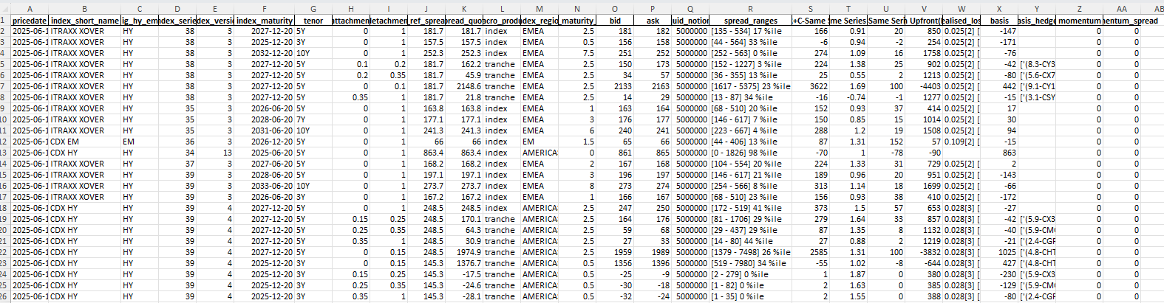

  - Index/Tranche Pair Trade Analysis:
        - Using -> Index/Tranche Properties generated from the above process

- Check duration difference is within the ‘duration product variance’ input
- Before regression analysis, calculate the beta_ratio between the pairs
  - If ‘duration weighted’ is ‘Y’, then quotes multiplied by duration ratio
  - Quotes are beta adjusted. Default set to historic regression method (option for regression done by CDS level). Then ‘beta sub method’ is defaulted to ‘rolling tenor exact to exact’ given start date to end date of the analysis. Other options are ‘rolling tenor’ or ‘exact to exact’
- Calculate the z score, standard deviation, average and percentile of the differences in quotes in the pair. Calculate past 6 months z score (date can be changed). Ensure both z’s are the same direction (directional strength testing to ensure relationships haven’t changed). Take the highest z as the target return
- Adjust for momentum scores and thus momentum spread pickup. If -0.1<score<0.1 assign 0. Not significant enough
- Calculate the total transaction cost of the pair trade. FX Adjusted
- Calculate maximum notional sizes for each pair that meets the maximum liquid notional sizes for each product
- Check whether the potential spread reversion pickup (FX Adjusted) plus the momentum spread is greater than the transaction cost in basis points. If not, skip to the next possible iteration of pairs
- Check the net direction of CR01 moves minus net transaction cost is profitable (spreads, duration and spread move from each leg of the pair). FX Adjusted
- Assign pair trade details (net carry, net rolldown+carry over inputted timeframe, % return on the trade vs cash usage, net basis)
- Filter results for net carry, target return (bps on notional) etc requirements

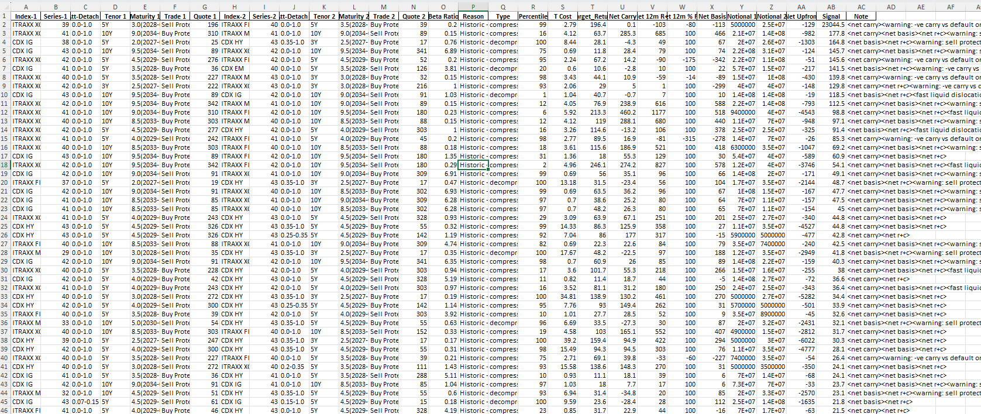
  - Results evaluation and trade selection:
Results signaling: Algorithmically evaluate and generate the signal scores on the strength of all the pair trades that has been picked up. Markov Chain methodology is used:

        - Net Carry = Base Score x (net carry/ABS(net carry)

        - +/- Net Basis= Base Score x (net basis/(ABS(net basis)+10/(ABS(net basis)))

        - +/- Net R+C = Net Score x (net r+c/net carry)

        - +/- Default Payout from Excess Notional = Net Score * (Target Return x min(duration)/Target Return

        - +/- Fast Liquid Dislocations = Carry signal reset, min threshold for IG is 3bps and HY is 15bps for index-to-index pair trades. Require immediate pair trade closure when target returns are met

        - Long Risk Index or Equity Tranche (default risk): carry signal reset
          - Expected defaults based on index weights, cds recoveries, expected number of defaults
          - Expected Net Return = Net carry to maturity – Expected default loss
          - +/- (Target Return + Expected Net Return)/Target Return x Base Score

+
+

Example Signal Results:
              - Signals over 50 from back testing provide the best results. The note section explains where the signal comes from

  - Portfolio and Risk Management:

      - Portfolio recorded in Excel (Trade notional, counterparties, traded spreads…)

      - Risk and PnL is generated ad hoc (Module of script created) over the excel. Risk and PnL can be seen in different ways such as portfolio, constituent tickers, or even on an individual trade level

      - Monitor and exit trades with ‘exceptional’ PnL (exceeds the total net carry to maturity PnL):
              - ‘CLOSE ME!’ flag: Current return ≥Total net carry to maturity return
              - ‘Y’ flag: Current return < Total net carry to maturity return

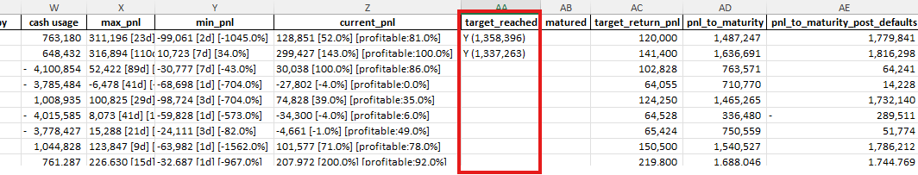

      - Risk can be managed through multiple views, and the portfolio can be tailored (but not limited to the below):
        - Portfolio Level by product sector: Delta adjusted CR01 is shown by duration buckets. Total carry, cash usage (upfront and margin), annualized expected default losses and the current index equivalent hedge is shown and calculated
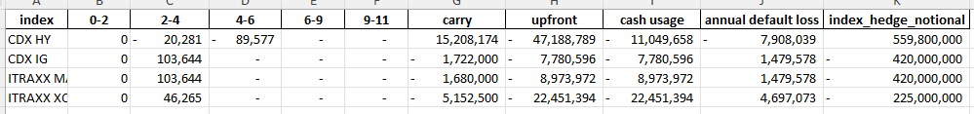
        - Single name CDS exposures: Index and tranche (based on net asset value methodology) constituents are aggregated to show net total CR01 and notional exposures for each issuer. Note, views on single name CDS can be taken here for hedging or additional alpha. A pair trade finder has also been developed which can be modified to neutralize single name CDS exposures
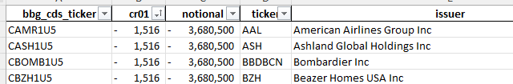
        - Portfolio performance to date: Daily PnL, cash usage, cr01 and so forth can charted to see the portfolios performance over set periods

EXAMPLE PORTFOLIO TRADES:
Back Testing – Index/Tranche
Analysis Procedure

      - Automated trade selection process: Dates are inputted to find and select, if possible, the top 10 trades as per the signaler logic (dates picked at unoptimized scenarios!). Note: No single pair trade is repeated/grown for any specified date. Max trade size and traded levels are based off the liquidity and transaction cost algorithm

      - Standard parameters set for trade selection universe:
        - Pricing Source: Markit,
        - Target Return: Min 10bps (on notional 1), Minimum Absolute Return >50k
        - Cash Benchmarked: Yes,
        - Duration Weighted: No,
        - Forward Momentum=’N’,
        - Duration Product Variance: 1.25yrs,
        - Maturity Range: 3.3-7.2yr,
        - Equity Tranche: ‘N’,
        - CDS Series Inclusion: Ignore 6 years or older,
        - Beta Calculation Method: Historic,
        - Beta Sub Method: rolling tenor to exact to exact,
        - beta data filter=’Y’
        - CDS Exclusion = CDX EM
        - Index Products Included: iTraxx Main/Xover/Fins Snr/Fins Sub, CDS IG/HY
        - FX Conversion = ‘EUR’

      - PnL life (traded date) to now is calculated (Max, Min, Current PnL, and % profitable in period)
        - Realized default losses/gains (actual recovery prices used)
        - Cash Usage Cost (Net of Upfront and Margin)
        - Carry
        - Rolldown/Spread Move (Current Duration x Spread ∆)

      - Daily Cumulative PnL/Risk/Upfront/Cash Usage is charted for two situations in each systematic framework:
        - Portfolio Pairs -> no trades closed
        - Closing Pairs -> trades closed when the target return is met. Trades aren’t replaced

Note: Annualized returns below:
- Log returns are used given the portfolio is scaled up over time without closing trades
- Closing pairs do not have pairs replaced with new trades. More pairs on average are added then closed by nature
- Returns are based off PnL against cash usage (Net Upfront + Margin Requirements)
- Any pair trades with negative cash usages are automatically given returns of 100% if the PnL is greater than 0, and PnL less than 0 is given -100%

Other considerations:
- IG: 0.6 Recovery, HY:0.2 Recovery
- Defaults: CDX IG (3/125), CDX HY (8/100), ITRX MAIN (3/125), ITRX XOVER (8/75), ITRX SNR FIN (2/30), ITRX SUB FIN (2/30)
- Cash Usage will have a 4% benchmark rate. Margin requirements are always greater than or equal to 0
- Portfolio comparisons against vanilla long only index/tranche are based off annualized returns with no spread movement. Assuming held to maturity and notionals sized to match the current snapshot carry of ‘my portfolio as of now’. Negative cash will be converted to positive to work out returns

Back Testing: between 2021-2025

              - Dates picked: ['2021-02-15', '2021-07-20', '2021-12-15', '2022-03-16', '2022-05-22', '2022-07-07','2022-12-22', '2023-02-23', '2023-05-03', '2023-08-15', '2023-12-05', '2024-01-15','2024-04-16', '2024-06-25', '2024-08-08', '2024-09-27', '2024-11-21', '2025-02-19','2025-04-07']
              - Purposely didn’t pick many dates in 2022, as there would have been lots of trades with dislocations which you want and then would have generated significantly higher PnL in the long run
              - Realistically, more trades should be selected in volatile moments with big spreads moves
              - Purpose is to show a worst-case trading of this strategy that still delivers performance. 2021-2025 had remarkable macro events and conditions to test my systematic model

iTraxx Main 5Yr + Dates the trades are selected:

Note, the significant macro events that occurred between 2021 to now:
  - The Russian invasion of Ukraine (2022)
  - EU Gas Crisis (Summer 2022)
  - Stagflation and huge base rate hiking
  - UK/France/Germany/US elections. Votes of no confidence, far right fears, Trump Elected (2024 3/4Q)
  - Trump Tariff Crisis (Back and forth, rollbacks and delays) and US Recession Risks (1H 2025). Extraordinary levels of volatility only ever been seen a handful of times, clustered around selloffs driven by recession fears (2008, 2011-2012), COVID (2020), and the EU Gas Crisis (2022)

Positive Carry Trades (2021-2025):
Only trades with net carry greater than 0 are selected from the standard parameters and dates picked
Holding Pairs:
Annualized PnL | Annualized Return | PnL Growth Rate (Log, per mm) | Drawdown
31.6mm | 85% | 115% | Temporary, 100% of Annual PnL

 | Carry | Upfront | Raw Return | CR01 | Notional | Cash | Default Loss (exp) | Return (post loss vs cash)
My Portfolio | 40.1mm | 6.4mm | 627% | 0 | n/a | 131mm | -10.4mm | 22.7%
vs
IG Index  (~60bps, Cpn 100bps  2 Defaults, 40% Recovery) | 40.1mm | 120mm | 33.4% | -3mm | 6.7bn | 250mm | -12.8mm | 10.9%
HY Index  (~270bps, Cpn 500bps  5 Defaults, 20% Recovery) | 40.1mm | 145mm | 27.7% | -670k | 1.5bn | 280mm | -16mm | 8.6%
In 2022, betas broke. Positive carry trades tend to be positive gamma and explains temporary mark to market impacts and variable margin increases. As carry accumulates and pairs revert, PnL makes a strong recovery. PnL generation becomes significant as the portfolio grows

Closing Pairs:
Closing trades when the target return is met, shows PnL makes a mechanical and more transitioned increase, albeit less than keeping them open. Trades closed aren’t replaced, so PnL plateaus and makes jumps as the years go by. Signaler works. Majority trades get closed out

Negative Carry Trades (2021-2025):
Only trades with net carry less than 0 are selected from the standard parameters and dates picked
Holding Pairs:
Annualized PnL | Annualized Return | PnL Growth Rate (Log, per mm) | Drawdown
-5.5mm | -81% | n/a | Temporary, +20mm Spike

 | Carry | Upfront | Raw Return | CR01 | Notional | Cash | Default Loss (exp) | Return (post loss vs cash)
My Portfolio | -10.7mm | -150.5mm | -7.1% | 0 | n/a | -155mm | +5.4mm | -3.5%
vs
IG Index  (~60bps, Cpn 100bps  2 Defaults, 40% Recovery) | -10.7mm | -32mm | -33.4% | +802k | 1.8bn | 4mm | +3.4mm | -182.5%
HY Index  (~270bps, Cpn 500bps  5 Defaults, 20% Recovery) | -10.7mm | -39mm | -27.4% | +178k | 400mm | -3mm | +4.2mm | -216.7%

As trades are systematically added, PnL is positive at the start showing trades have mean reversions. Since trades aren’t closed, negative carry then starts to eat at the PnL as you would expect

Closing Pairs:
The upward cumulative PnL indicates that the model to find pair trades works. The target returns are being met, and the pair trades are closed out despite the negative carry bleed that could have occurred

Greater than >-25bps Carry Trades (2021-2025):
Only trades with net carry greater than -25bps are selected from the standard parameters and dates picked. We don’t want to exclude potential neg gamma/certain trades that could have high signals despite some negative carry
Holding Pairs:
Annualized PnL | Annualized Return | PnL Growth Rate (Log, per mm) | Drawdown
33mm | 254% | 107% | Temporary, 100% of Annual PnL

 | Carry | Upfront | Raw Return | CR01 | Notional | Cash | Default Loss (exp) | Return (post loss vs Cash)
My Portfolio | 36.6mm | -72mm | >100% | 0 | n/a | -30mm | -7.5mm | >100%
vs
IG Index  (~60bps, Cpn 100bps  2 Defaults, 40% Recovery) | 36.6mm | 110mm | 33.3% | -2.75mm | 6.1bn | 232mm | -11.8mm | 10.7%
HY Index  (~270bps, Cpn 500bps  5 Defaults, 20% Recovery) | 36.6mm | 133mm | 27.5% | -610k | 1.4bn | 259mm | -14.4mm | 8.6%

Less volatility while maintaining super strong returns when compared to all positive carry trades

Closing Pairs:
Targets are being met from the pair trades found and selected given the positive PnL growth. Trades aren’t replaced, which explains the PnL plateauing

Optimum Trades (2021-2025):
- > -25bps Net Carry
- > 10% Return (vs cash usage)
- CDS Inclusion: Recent 3 Series at the time
Holding Pairs:
Annualized PnL | Annualized Return | PnL Growth Rate (Log, per mm) | Drawdown
33mm | 100% (infinite) | 116% | Temporary, 75% PnL

 | Carry | Upfront | Raw Return | CR01 | Notional | Cash | Default Loss | Return (post loss vs cash)
My Portfolio | 35.7mm | -322mm | >100% | 0 | n/a | -210mm | -8.6mm | >100%
vs
IG Index  (~60bps, Cpn 100bps  2 Defaults, 40% Recovery) | 35.7mm | 107mm | 33.4% | -2.7mm | 5.95bn | 226mm | -11.5mm | 10.7%
HY Index  (~270bps, Cpn 500bps  5 Defaults, 20% Recovery) | 35.7mm | 130mm | 27.5% | -600k | 1.3bn | 247mm | -14mm | 8.8%
IG 3-6% Tranche  (~160bps, Cpn 100bps) | 35.7mm | -53mm | >100% | 1mm x 2.1 delta | 2.4bn | 48mm | 0 | 74%
HY 10-20% Tranche  (~440bps, Cpn 500bps) | 35.7mm | 22mm | 162% | 365k x 2.4 delta | 811mm | 197mm | 0 | 18.1%
Compared with ‘positive carry’ and ‘optimum >-25bps’ trades only, these additionally filtered optimum trades provide less mark to market volatility while providing higher annualized PnL

Closing Pairs:

Targets are being met from the pair trades found and selected given the positive PnL growth

Back Testing: between 2024-2025
              - Using the same parameters set as mentioned earlier like in the 2021-2025 back tests
              - The purpose of this analysis, is to show when many trades are put on in a low volatile environment where dislocations are smaller, the strategy and algorithm still generates positive performance and results
              - Dates picked: ['2024-02-02', '2024-03-22', '2024-04-19', '2024-06-04','2024-06-26','2024-07-23','2024-08-07','2024-09-26','2024-11-27','2024-12-11', '2025-01-31','2025-02-26','2025-03-28', '2024-04-04','2025-04-10']

iTraxx Main 5Yr + Dates the trades are selected:

Note, the significant macro events that occurred between 2021 to now:
  - US Recessional Fears (1H 2024)
  - Rounds of far-right fears in the French Elections (2h 2024)
  - Trump presidency win (October 2024)
  - ‘Post Liberation Day’ sell off. Reciprocal Tariffs implemented globally. Followed by de-escalation with trade talks and 90-day reliefs. (30-40bps Main move)
  - French parliamentary volatility (PM Lecornu stepping down)

Positive Carry Only Trades (2024-2025):
Only trades with net carry greater than 0 are selected from the standard parameters and dates picked
Holding Pairs:
Annualized PnL | Annualized Return | PnL Growth Rate (Log, per mm) | Drawdown
23mm | 30% | 210% | Temporary, 200% of Annual PnL

 | Carry | Upfront | Raw Return | CR01 | Notional | Cash | Default Loss (exp) | Return (post loss vs cash)
My Portfolio | 20.5mm | 14mm | 146% | 0 | n/a | 75mm | -7.6mm | 17.2%
vs
IG Index  (~60bps, Cpn 100bps  2 Defaults, 40% Recovery) | 20.5mm | 61.5mm | 28.3% | -1.5mm | 3.4bn | 130mm | -6.5mm | 10.8%
HY Index  (~270bps, Cpn 500bps  5 Defaults, 20% Recovery) | 20.5mm | 74mm | 22.7% | -341k | 760mm | 143mm | -8mm | 8.7%

Strong positive PnL growth. Skewed toward long gamma explaining the temporary unrealized mark to market impact in April 2025, equivalent to up to 100% PnL generated in a year

Closing Pairs:

Negative Carry Only Trades (2024-2025):
Only trades with net carry less than 0 are selected from the standard parameters and dates picked
Holding Pairs:
Annualized PnL | Annualized Return | PnL Growth Rate (Log, per mm) | Drawdown
-6.2mm | -100% | n/a | Temporary, +15mm spike

 | Carry | Upfront | Raw Return | CR01 | Notional | Cash | Default Loss | Return (post loss vs cash)
My Portfolio | -6.6mm | -57mm | -11.6% | 0 | n/a | -23mm | 2.3mm | -18.7%
Vs
IG Index  (~60bps, Cpn 100bps  2 Defaults, 40% Recovery) | -6.6mm | -19.8mm | -33.3% | 495k | 1.1bn | 2.2mm | 2.1mm | -204%
HY Index  (~270bps, Cpn 500bps  5 Defaults, 20% Recovery) | -6.6mm | -24mm | -27.5% | 110k | 245mm | -2mm | 2.6mm | -200%

Closing Pairs:
Despite the negative carry bleed, the model targets are being reached. PnL remain flat lined, until a big sell off in April 2025. Majority of the negative carry trades are short gamma, explaining PnL spike, and trades closed out

Greater than -25bps Carry Trades (2024-2025):
Only trades with net carry greater than -25bps are selected from the standard parameters and dates picked. We don’t want to exclude potential neg gamma/certain trades that could have high signals despite some negative carry
Holding Pairs:
Annualized PnL | Annualized Return | PnL Growth Rate (Log, per mm) | Drawdown
9.8mm | 27% | 160% | Temporary, 150% of Annual PnL

 | Carry | Upfront | Raw Return | CR01 | Notional | Cash | Default Loss | Return (post loss vs cash)
My Portfolio | 7.1mm | -7.7mm | >100% | 0 | n/a | 36mm | -3.4mm | >100%
vs
IG Index  (~60bps, Cpn 100bps  2 Defaults, 40% Recovery) | 7.1mm | 21.3mm | 33.3% | -533k | 1.18bn | 45mm | -2.3mm | 10.7%
HY Index  (~270bps, Cpn 500bps  5 Defaults, 20% Recovery) | 7.1mm | 25.7mm | 27.6% | -118k | 263mm | 50mm | -2.8mm | 8.6%

Closing Pairs:

Optimum Trades (2024-2025):
- > -25bps Net Carry
- > 10% Return (vs cash usage)
- CDS Inclusion: Recent 3 Series at the time
Holding Pairs:
Annualized PnL | Annualized Return | PnL Growth Rate (Log, per mm) | Drawdown
30mm | 100% | 225% | Temporary, 100% of Annual PnL

 | Carry | Upfront | Raw Return | CR01 | Notional | Cash | Default Loss | Return (post loss vs cash)
My Portfolio | 19.5mm | -263mm | >100% | 0 | n/a | -184mm | -5.7mm | >100%
vs
IG Index  (~60bps, Cpn 100bps  2 Defaults, 40% Recovery) | 19.5mm | 58.5mm | 33.3% | -1.4mm | 3.25bn | 124mm | -6.2mm | 10.7%
HY Index  (~270bps, Cpn 500bps  5 Defaults, 20% Recovery) | 19.5mm | 70.5mm | 27.7% | -325k | 722mm | 135.5mm | -7.7mm | 8.7%
IG 3-6% Tranche  (~160bps, Cpn 100bps) | 19.5mm | -33mm | >100% | 548k x 2.1 delta | 1.2bn | 18mm | 0
HY 10-20% Tranche  (~440bps, Cpn 500bps) | 19.5mm | 12mm | 157% | 200k x 2.4 delta | 444mm | 108mm | 0

PnL performance is a lot more consistent, durable and upward trending in this trade selection process when compared to the other cases in 2024-2025

Closing Pairs:

Back Testing Takeaways:

Note:

  - In most cases, cash usage requirements are relatively low. Starting cash needs are between -50mm to +50mm, then later trending towards negative as PnL grows. Mark to market volatility may make margin demands temporarily spike up to 150mm when the book is large (built over many years) and are all positive carry trades. Otherwise, the optimum trade structure demands far less

  - PnL is based on EOD prices. Traded levels can be better than the EOD marks

  - Only the selected top pairs chosen are put on uniquely. It is possible to grow the same pair, taking advantage of the higher projected return and strong signal which hasn’t been displayed here

  - Drawdowns are temporary: April 2024 had one of the most extreme levels of volatility from unnatural causes (as big as GFC 2008, COVID 2020, EU/Gas Crisis 2022). Market to market swings were temporary and Pnl reverts over the long term

  - FX Impacts are relatively small, +/- 2-3mm when carry is 30mm per year. Smaller the portfolio, smaller the FX impacts if unhedged

  - No hedging or discretionary views or historic data adjustments or bias trades were made in the analysis. If so, then additional alpha could have been generated

  - Buying protection on super low spread (<50bps) indices/tranches or single name CDS were not used. Otherwise, it could have reduced the upfront/margin/cash usage needs generating greater average annual returns in the years needed

Summary of back test results:
 |  | Optimum Trades, > -25bps Carry, >10% Rtn, Recent 3 Series | All Carry Positive | All Carry Negative
1- Pairs Held | PnL #1 | High | High | Negative
1- Pairs Held | PnL Volatility | Medium | High | Low
1- Pairs Held | Cash Usage | Neutral | Positive-Low | Negative-High
1- Pairs Held | Level of Ease | High | High | High
2-Close Pairs on Target Return | PnL #1 | Medium | Medium | Low
2-Close Pairs on Target Return | PnL Volatility | Low-Medium | Low-Medium | Low
2-Close Pairs on Target Return | Cash Usage | Negative-Low | Positive-Low | Negative-Low
2-Close Pairs on Target Return | Level of Ease | Low | Low | Low

In depth back test: Starting off mid-year + Worst timing for adding trades in 2025-:
- Parameters: > -25bps Net Carry, >100k Net carry to maturity, Recent 3 series. Rest is the same
- Ad hoc trades selected from results. PnL generated to 10/10/2025
- This example is used as if the strategy was to be implemented in the most non ideal timing possible. Showcasing my strategies profitability

Portfolio Summary (as of 10/10/2025):
 | Duration Buckets (absolute CR01)
Product Level | 0-2 | 2-4 | 4-6 | 6-9 | 9-11 | upfront | cash usage | carry (annual) | expected default loss (annual) | expected net carry return (annual) |  | index hedge notional | spread | hedge carry (annual) |  | Final Net Return (annual)
CDX HY | - | - 8,099 | - 52,392 | - | - | - 14,282,263 | - 2,264,443 | 5,029,691 | - 4,476,063 | 553,628 |  | 387,800,000 | 330 | - 12,797,400 |  | - 12,243,772
CDX IG | - | 51,783 | - | - | - | - 2,606,219 | - 2,606,219 | - 574,000 | 1,479,578 | 905,578 |  | - 420,000,000 | 53 | 2,226,000 |  | 3,131,578
ITRAXX MAIN | - | 51,783 | - | - | - | - 2,990,854 | - 2,990,854 | - 560,000 | 1,479,578 | 919,578 |  | - 420,000,000 | 57 | 2,394,000 |  | 3,313,578
ITRAXX XOVER | - | 27,741 | - | - | - | - 7,482,591 | - 7,482,591 | - 1,717,500 | 4,697,073 | 2,979,573 |  | - 225,000,000 | 280 | 6,300,000 |  | 9,279,573
 |  |  |  |  |  |  |  |  | PnL: | 5,358,357 |  |  | PnL (If fully hedged): |  |  | 3,480,957

Performance to date (10/10/2025):

Trades selected:
Trade # | Trade Date | Trade 1 | Att-Detach 1 | B/S 1 | Trade 2 | Att-Detach 2 | B/S 2 | Net Carry | Notional 1 | Notional 2 | Quote 1 | Quote 2 | Cash usage | current_pnl | target reached | target return pnl | pnl to maturity | pnl to maturity post defaults
1 | 11 June 2025 | ITRAXX XOVER 41 5Y | 0.0-1.0 | Buy | CDX HY 43 5Y | 0.0-1.0 | Sell | 65.6 | 25,000,000 | 26,900,000 | 243 | 323 | 799,769 | 146,988 [56.0%] [profitable:81.0%] | Y (1,340,259) | 120,000 | 1,487,247 | 1,779,841
2 | 11 June 2025 | CDX IG 42 5Y | 0.0-1.0 | Buy | CDX HY 43 5Y | 0.0-1.0 | Sell | 18.6 | 140,000,000 | 27,000,000 | 41 | 323 | 672,050 | 299,435 [137.0%] [profitable:100.0%] | Y (1,337,255) | 141,400 | 1,636,691 | 1,816,298
3 | 11 June 2025 | CDX HY 43 5Y | 0.0-1.0 | Sell | CDX HY 43 5Y | 0.35-1.0 | Buy | 126.4 | 11,400,000 | 35,000,000 | 323 | 57 | - 4,127,075 | 34,583 [100.0%] [profitable:86.0%] |  | 102,828 | 763,571 | 64,241
4 | 29 July 2025 | CDX HY 43 5Y | 0.0-1.0 | Sell | CDX HY 43 5Y | 0.35-1.0 | Buy | 124.5 | 11,500,000 | 35,000,000 | 305 | 54 | - 3,803,514 | -23,454 [-3.0%] [profitable:0.0%] |  | 64,055 | 710,770 | 14,228
5 | 29 July 2025 | ITRAXX XOVER 41 5Y | 0.0-1.0 | Buy | CDX HY 43 5Y | 0.0-1.0 | Sell | 71.5 | 25,000,000 | 27,200,000 | 224 | 305 | 1,046,465 | 91,951 [45.0%] [profitable:37.0%] |  | 124,250 | 1,465,265 | 1,732,140
6 | 29 July 2025 | CDX HY 42 5Y | 0.0-1.0 | Sell | CDX HY 43 5Y | 0.35-1.0 | Buy | 89 | 10,900,000 | 35,000,000 | 275 | 54 | - 4,038,410 | -26,229 [-3.0%] [profitable:6.0%] |  | 64,528 | 336,480 | -289,511
7 | 18 August 2025 | CDX HY 43 5Y | 0.0-1.0 | Sell | CDX HY 43 5Y | 0.35-1.0 | Buy | 126 | 11,600,000 | 35,000,000 | 306 | 52 | - 3,788,648 | -231 [-0.0%] [profitable:47.0%] |  | 65,424 | 750,559 | 51,774
8 | 18 August 2025 | ITRAXX XOVER 41 5Y | 0.0-1.0 | Buy | CDX HY 43 5Y | 0.0-1.0 | Sell | 75.4 | 25,000,000 | 27,500,000 | 220 | 306 | 1,082,703 | 118,533 [78.0%] [profitable:79.0%] |  | 150,500 | 1,540,527 | 1,786,212
9 | 18 August 2025 | ITRAXX MAIN 41 5Y | 0.0-1.0 | Buy | CDX HY 43 5Y | 0.0-1.0 | Sell | 14.5 | 140,000,000 | 28,900,000 | 40 | 306 | 801,142 | 215,361 [193.0%] [profitable:92.0%] |  | 219,800 | 1,688,046 | 1,744,769
10 | 15 Sept 2025 | CDX HY 42 5Y | 0.0-1.0 | Sell | CDX HY 43 5Y | 0.35-1.0 | Buy | 89.6 | 11,000,000 | 35,000,000 | 261 | 48 | - 3,988,589 | -10,159 [-4.0%] [profitable:33.0%] |  | 61,600 | 363,859 | -258,251
Additional trade details:
Trade # | Trade Date | Trade 1 | Att-Detach 1 | B/S 1 | Trade 2 | Att-Detach 2 | B/S 2 | Type | Beta Ratio | Signal | Net Upfront | max_pnl | min_pnl | current_pnl
1 | 11 June 2025 | ITRAXX XOVER 41 5Y | 0.0-1.0 | Buy | CDX HY 43 5Y | 0.0-1.0 | Sell | compression | 0.93 | 39.5 | - 782,947 | 311,194 [23d] [408.0%] | -99,061 [2d] [-1040.0%] | 146,988 [56.0%] [profitable:81.0%]
2 | 11 June 2025 | CDX IG 42 5Y | 0.0-1.0 | Buy | CDX HY 43 5Y | 0.0-1.0 | Sell | compression | 5.18 | 38.3 | - 916,550 | 317,199 [110d] [148.0%] | 10,743 [7d] [34.0%] | 299,435 [137.0%] [profitable:100.0%]
3 | 11 June 2025 | CDX HY 43 5Y | 0.0-1.0 | Sell | CDX HY 43 5Y | 0.35-1.0 | Buy | compression | 0.32 | 30.2 | - 4,819,379 | 52,355 [20d] [100.0%] | -30,782 [7d] [-43.0%] | 34,583 [100.0%] [profitable:86.0%]
4 | 29 July 2025 | CDX HY 43 5Y | 0.0-1.0 | Sell | CDX HY 43 5Y | 0.35-1.0 | Buy | compression | 0.33 | 39.9 | - 4,551,770 | -6,511 [41d] [-2.0%] | -68,699 [1d] [-700.0%] | -23,454 [-3.0%] [profitable:0.0%]
5 | 29 July 2025 | ITRAXX XOVER 41 5Y | 0.0-1.0 | Buy | CDX HY 43 5Y | 0.0-1.0 | Sell | compression | 0.92 | 26.3 | - 723,323 | 100,822 [29d] [90.0%] | -98,724 [3d] [-700.0%] | 91,951 [45.0%] [profitable:37.0%]
6 | 29 July 2025 | CDX HY 42 5Y | 0.0-1.0 | Sell | CDX HY 43 5Y | 0.35-1.0 | Buy | compression | 0.31 | 21.8 | - 4,568,264 | 8,041 [41d] [100.0%] | -59,829 [1d] [-569.0%] | -26,229 [-3.0%] [profitable:6.0%]
7 | 18 August 2025 | CDX HY 43 5Y | 0.0-1.0 | Sell | CDX HY 43 5Y | 0.35-1.0 | Buy | compression | 0.33 | 42.7 | - 4,559,703 | 15,271 [21d] [100.0%] | -24,114 [3d] [-82.0%] | -231 [-0.0%] [profitable:47.0%]
8 | 18 August 2025 | ITRAXX XOVER 41 5Y | 0.0-1.0 | Buy | CDX HY 43 5Y | 0.0-1.0 | Sell | compression | 0.91 | 35.2 | - 745,228 | 123,846 [9d] [348.0%] | -63,983 [1d] [-1553.0%] | 118,533 [78.0%] [profitable:79.0%]
9 | 18 August 2025 | ITRAXX MAIN 41 5Y | 0.0-1.0 | Buy | CDX HY 43 5Y | 0.0-1.0 | Sell | compression | 4.85 | 28.3 | - 1,119,847 | 226,628 [15d] [453.0%] | -32,687 [1d] [-959.0%] | 215,361 [193.0%] [profitable:92.0%]
10 | 15 September 2025 | CDX HY 42 5Y | 0.0-1.0 | Sell | CDX HY 43 5Y | 0.35-1.0 | Buy | compression | 0.31 | 22.5 | - 4,574,916 | 9,800 [8d] [100.0%] | -29,103 [14d] [-19.0%] | -10,159 [-4.0%] [profitable:33.0%]

In depth back test: How I would have traded 2025 starting off:
- Parameters: > -25bps Net Carry, >100k Net carry to maturity, Recent 3 series. Rest is the same
- Top 3 trades for each date. PnL generated to 10/10/2025
- This shows how you should have traded 2025 starting off
- Note: Hedging(using index) below right isnt required as the expected net carry return is after any defaults

Portfolio Summary (as of 10/10/2025):
 | Duration Buckets (absolute CR01)
Product Level | 0-2 | 2-4 | 4-6 | 6-9 | 9-11 | upfront | cash usage | carry (annual) | expected default loss (annual) | expected net carry return (annual) |  | index hedge notional | spread | hedge carry (annual) |  | Final Net Return (annual)
CDX HY | - | 16,008 | - 164,605 | - | - | 2,788,247 | 28,455,292 | 11,927,606 | - 10,480,152 | 1,447,454 |  | 758,300,000 | 330 | - 25,023,900 |  | - 23,576,446
CDX IG | - | 26,332 | - 248,523 | - | - | - 5,553,795 | 10,977,352 | 2,571,829 | 980,205 | 3,552,034 |  | - 248,100,000 | 53 | 1,314,930 |  | 4,866,964
ITRAXX MAIN | - | - | 97,682 | - | - | - 11,038,899 | - 8,462,962 | - 1,157,479 | 2,046,550 | 889,071 |  | - 636,300,000 | 57 | 3,626,910 |  | 4,515,981
ITRAXX XOVER | - | 2,228 | 76,125 | - | - | - 44,547,912 | - 40,740,687 | - 4,499,240 | 5,188,650 | 689,410 |  | - 287,100,000 | 280 | 8,038,800 |  | 8,728,210
ITRAXX FINS SUB | - | 9,206 | - | - | - | - 108,802 | - 108,802 | - 227,500 | 379,512 | 152,012 |  | - 50,000,000 | 105 | 525,000 |  | 677,012
 |  |  |  |  |  |  |  |  | PnL: | 6,729,981 |  |  | PnL (If fully hedged): |  |  | - 4,788,279
Performance to date (10/10/2025):

Trades selected:
Trade  # | Trade Date | Trade 1 | Att-Detach 1 | B/S 1 | Trade 2 | Att-Detach 2 | B/S 2 | Net Carry | Notional 1 | Notional 2 | Quote 1 | Quote 2 | cash usage | current pnl | target reached | target return  pnl | pnl to maturity | pnl to maturity  post defaults
1 | 10 January 2025 | ITRAXX MAIN 42 5Y | 0.03-0.06 | Sell | CDX HY 41 5Y | 0.35-1.0 | Buy | 38.2 | 2,900,000 | 15,000,000 | 215 | 34 | - 2,040,486 | 115,652 [100%] [profitable:100.0%] | CLOSE ME! | 59,363 | 107,055 | 107,055
2 | 10 January 2025 | ITRAXX XOVER 42 5Y | 0.35-1.0 | Buy | CDX HY 43 5Y | 0.0-1.0 | Sell | 366.9 | 34,500,000 | 50,000,000 | 92 | 318 | - 465,491 | 1,410,977 [100.0%] [profitable:72.0%] | Y (4,877,983) | 108,330 | 6,288,961 | 3,104,669
3 | 10 January 2025 | CDX HY 43 5Y | 0.15-0.25 | Sell | CDX HY 41 5Y | 0.35-1.0 | Buy | 163.2 | 2,300,000 | 15,000,000 | 395 | 34 | - 1,853,632 | 118,289 [100.0%] [profitable:93.0%] | Y (129,607) | 63,986 | 247,897 | 247,897
4 | 10 March 2025 | CDX IG 43 5Y | 0.03-0.07 | Sell | ITRAXX XOVER 42 5Y | 0.35-1.0 | Buy | 4.3 | 15,000,000 | 34,200,000 | 218 | 86 | - 5,193,500 | 273,153 [100.0%] [profitable:88.0%] | CLOSE ME! | 79,800 | 157,176 | 157,176
5 | 10 March 2025 | CDX IG 43 5Y | 0.03-0.07 | Sell | CDX IG 41 5Y | 0.0-1.0 | Buy | 10.8 | 15,000,000 | 82,700,000 | 218 | 37 | - 360,911 | 321,359 [100.0%] [profitable:97.0%] | Y (84,855) | 81,000 | 406,214 | 1,460,970
6 | 10 March 2025 | CDX IG 43 5Y | 0.07-0.15 | Sell | ITRAXX XOVER 40 5Y | 0.0-1.0 | Buy | 2.8 | 25,000,000 | 7,000,000 | 72 | 229 | - 153,973 | 116,086 [100.0%] [profitable:85.0%] |  | 140,250 | 254,362 | 783,417
7 | 21 March 2025 | CDX HY 43 5Y | 0.15-0.25 | Sell | CDX HY 41 5Y | 0.15-0.25 | Buy | 142.6 | 5,000,000 | 4,500,000 | 447 | 325 | 480,805 | 149,871 [56.0%] [profitable:76.0%] | Y (363,229) | 60,850 | 513,101 | 513,101
8 | 21 March 2025 | ITRAXX XOVER 42 5Y | 0.35-1.0 | Buy | CDX IG 43 5Y | 0.07-0.15 | Sell | 201.2 | 6,000,000 | 25,000,000 | 87 | 71 | - 573,374 | 222,160 [100.0%] [profitable:78.0%] | Y (373,036) | 76,740 | 595,196 | 595,196
9 | 21 March 2025 | ITRAXX FINS SUB 41 5Y | 0.0-1.0 | Buy | CDX IG 43 5Y | 0.03-0.07 | Sell | 6.7 | 25,000,000 | 11,300,000 | 91 | 215 | 815,234 | 72,664 [16.0%] [profitable:65.0%] |  | 89,250 | 187,374 | 1,120,035
10 | 08 April 2025 | ITRAXX XOVER 42 5Y | 0.2-0.35 | Buy | ITRAXX XOVER 42 5Y | 0.1-0.2 | Sell | 188.3 | 7,500,000 | 5,000,000 | 346 | 776 | 399,067 | 382,981 [189.0%] [profitable:97.0%] | Y (221,083) | 70,725 | 604,064 | 604,064
11 | 08 April 2025 | ITRAXX XOVER 42 5Y | 0.2-0.35 | Buy | ITRAXX MAIN 42 5Y | 0.06-0.12 | Sell | 180.5 | 5,600,000 | 20,000,000 | 346 | 140 | - 192,935 | 143,855 [100.0%] [profitable:96.0%] | Y (261,549) | 76,104 | 405,405 | 405,405
12 | 08 April 2025 | ITRAXX MAIN 42 5Y | 0.12-1.0 | Buy | ITRAXX MAIN 42 5Y | 0.03-0.06 | Sell | 317.4 | 7,400,000 | 10,000,000 | 37 | 252 | 438,418 | 502,517 [226.0%] [profitable:97.0%] | Y (553,396) | 174,048 | 1,055,914 | 1,055,914
13 | 14 April 2025 | ITRAXX XOVER 42 5Y | 0.35-1.0 | Buy | CDX HY 44 5Y | 0.0-1.0 | Sell | 427.6 | 34,700,000 | 50,000,000 | 115 | 420 | - 1,347,396 | 2,489,848 [100.0%] [profitable:93.0%] | Y (6,524,595) | 91,261 | 9,014,443 | 5,766,081
14 | 14 April 2025 | CDX IG 43 5Y | 0.03-0.07 | Sell | ITRAXX MAIN 42 5Y | 0.12-1.0 | Buy | 110.1 | 15,000,000 | 51,100,000 | 262 | 35 | - 199,283 | 509,952 [100.0%] [profitable:93.0%] | Y (493,225) | 79,050 | 1,003,178 | 1,003,178
15 | 14 April 2025 | CDX HY 44 5Y | 0.0-1.0 | Sell | ITRAXX MAIN 42 5Y | 0.12-1.0 | Buy | 292 | 50,000,000 | 110,000,000 | 420 | 35 | 1,466,086 | 2,367,116 [329.0%] [profitable:94.0%] | Y (6,713,144) | 110,000 | 9,080,260 | 5,831,897
16 | 22 May 2025 | CDX IG 43 5Y | 0.07-0.15 | Sell | ITRAXX XOVER 42 5Y | 0.35-1.0 | Buy | 2.7 | 25,000,000 | 17,500,000 | 68 | 82 | - 2,551,769 | 63,052 [100.0%] [profitable:75.0%] | Y (58,329) | 57,000 | 121,381 | 121,381
17 | 22 May 2025 | CDX IG 43 5Y | 0.03-0.07 | Sell | ITRAXX XOVER 42 5Y | 0.2-0.35 | Buy | 31.3 | 14,700,000 | 10,000,000 | 205 | 222 | 83,903 | 117,021 [361.0%] [profitable:80.0%] | Y (246,435) | 56,742 | 363,457 | 363,457
18 | 22 May 2025 | CDX HY 43 5Y | 0.15-0.25 | Sell | ITRAXX XOVER 42 5Y | 0.2-0.35 | Buy | 7.4 | 5,000,000 | 7,900,000 | 405 | 222 | - 132,360 | 39,763 [100.0%] [profitable:75.0%] |  | 77,750 | 124,221 | 124,221
19 | 19 June 2025 | CDX HY 43 5Y | 0.0-1.0 | Sell | ITRAXX XOVER 42 5Y | 0.35-1.0 | Buy | 139.5 | 19,400,000 | 35,000,000 | 335 | 84 | - 3,910,430 | 210,281 [100.0%] [profitable:77.0%] | Y (1,392,608) | 93,314 | 1,602,890 | 415,287
20 | 19 June 2025 | CDX HY 43 5Y | 0.0-1.0 | Sell | CDX HY 41 5Y | 0.35-1.0 | Buy | 211.4 | 5,500,000 | 15,000,000 | 335 | 33 | - 1,292,476 | 114,563 [100%] [profitable:100.0%] | Y (541,785) | 66,770 | 656,348 | 319,657
21 | 19 June 2025 | CDX HY 43 5Y | 0.0-1.0 | Sell | ITRAXX XOVER 42 5Y | 0.2-0.35 | Buy | 139.2 | 15,000,000 | 10,000,000 | 335 | 230 | 640,136 | 27,513 [14.0%] [profitable:17.0%] |  | 94,800 | 1,227,276 | 309,026
22 | 01 August 2025 | ITRAXX MAIN 42 5Y | 0.0-1.0 | Buy | CDX HY 43 5Y | 0.0-1.0 | Sell | 2 | 212,100,000 | 40,000,000 | 52 | 326 | 905,046 | 143,205 [78.0%] [profitable:38.0%] |  | 341,481 | 881,944 | 1,349,308
23 | 01 August 2025 | CDX HY 41 5Y | 0.35-1.0 | Buy | CDX IG 43 5Y | 0.07-0.15 | Sell | 49.3 | 15,000,000 | 18,200,000 | 25 | 61 | - 1,341,091 | 112,473 [100%] [profitable:100.0%] | Y (247,462) | 51,900 | 359,936 | 359,936
24 | 01 August 2025 | CDX HY 43 5Y | 0.0-1.0 | Sell | CDX HY 41 5Y | 0.35-1.0 | Buy | 222.8 | 5,600,000 | 15,000,000 | 326 | 25 | - 1,130,722 | 117,172 [100%] [profitable:100.0%] | Y (556,540) | 81,592 | 673,713 | 334,802
25 | 01 September 2025 | ITRAXX XOVER 43 5Y | 0.0-1.0 | Buy | CDX HY 44 5Y | 0.0-1.0 | Sell | 18.3 | 49,200,000 | 50,000,000 | 269 | 325 | 2,517,701 | -14,724 [-5.0%] [profitable:12.0%] |  | 216,480 | 1,447,131 | 2,428,431
26 | 01 September 2025 | ITRAXX XOVER 43 5Y | 0.0-1.0 | Buy | CDX HY 43 5Y | 0.0-1.0 | Sell | 8.7 | 39,500,000 | 40,000,000 | 269 | 314 | 1,235,997 | 128,919 [89.0%] [profitable:16.0%] |  | 238,580 | 302,603 | 1,215,220
27 | 01 September 2025 | CDX HY 43 5Y | 0.0-1.0 | Sell | CDX HY 42 5Y | 0.0-1.0 | Buy | 38 | 25,600,000 | 25,000,000 | 314 | 276 | 1,720,438 | 118,391 [58.0%] [profitable:97.0%] | Y (716,961) | 68,608 | 835,353 | 719,474
28 | 25 September 2025 | CDX HY 43 5Y | 0.0-1.0 | Sell | CDX HY 43 5Y | 0.35-1.0 | Buy | 127.2 | 11,800,000 | 35,000,000 | 297 | 50 | - 3,712,898 | -15,301 [-10.0%] [profitable:0.0%] |  | 51,684 | 743,153 | 39,800
29 | 10 October 2025 | ITRAXX MAIN 44 5Y | 0.12-1.0 | Buy | CDX IG 45 5Y | 0.03-0.07 | Sell | 539.1 | 5,200,000 | 15,000,000 | 32 | 216 | 2,083,380 | -48,197 [-845.0%] [profitable:0.0%] |  | 56,784 | 1,596,337 | 1,596,337
30 | 10 October 2025 | ITRAXX MAIN 42 5Y | 0.12-1.0 | Buy | CDX IG 45 5Y | 0.03-0.07 | Sell | 541.2 | 5,300,000 | 15,000,000 | 24 | 216 | 2,095,035 | -48,266 [-841.0%] [profitable:0.0%] |  | 58,989 | 1,629,407 | 1,629,407
31 | 10 October 2025 | ITRAXX MAIN 42 5Y | 0.12-1.0 | Buy | ITRAXX XOVER 44 5Y | 0.1-0.2 | Sell | 187.2 | 11,800,000 | 5,000,000 | 24 | 480 | 1,691,676 | -26,317 [-568.0%] [profitable:0.0%] |  | 73,042 | 1,127,704 | 1,127,704
Additional trade details:
Trade # | Trade Date | Trade 1 | Att-Detach 1 | B/S 1 | Trade 2 | Att-Detach 2 | B/S 2 | Type | Beta Ratio | Signal | Net Upfront | max_pnl | min_pnl | current pnl
1 | 10 January 2025 | ITRAXX MAIN 42 5Y | 0.03-0.06 | Sell | CDX HY 41 5Y | 0.35-1.0 | Buy | compression | 0.19 | 164.1 | - 2,382,429 | 305,205 [273.0d] [100%] | 27,008 [89.0d] [100%] | 115,652 [100%] [profitable:100.0%]
2 | 10 January 2025 | ITRAXX XOVER 42 5Y | 0.35-1.0 | Buy | CDX HY 43 5Y | 0.0-1.0 | Sell | compression | 0.69 | 159.1 | - 3,105,875 | 1,544,946 [269.0d] [100.0%] | -2,088,953 [88.0d] [-200.0%] | 1,410,977 [100.0%] [profitable:72.0%]
3 | 10 January 2025 | CDX HY 43 5Y | 0.15-0.25 | Sell | CDX HY 41 5Y | 0.35-1.0 | Buy | compression | 0.15 | 151.9 | - 2,128,283 | 135,817 [262d] [100.0%] | -95,184 [88d] [-30.0%] | 118,289 [100.0%] [profitable:93.0%]
4 | 10 March 2025 | CDX IG 43 5Y | 0.03-0.07 | Sell | ITRAXX XOVER 42 5Y | 0.35-1.0 | Buy | compression | 0.44 | 971 | - 7,108,586 | 626,549 [30d] [100.0%] | -84,482 [2d] [-375.0%] | 273,153 [100.0%] [profitable:88.0%]
5 | 10 March 2025 | CDX IG 43 5Y | 0.03-0.07 | Sell | CDX IG 41 5Y | 0.0-1.0 | Buy | compression | 0.18 | 603.3 | - 2,275,997 | 1,031,615 [214.0d] [100.0%] | -78,408 [29.0d] [-82.0%] | 321,359 [100.0%] [profitable:97.0%]
6 | 10 March 2025 | CDX IG 43 5Y | 0.07-0.15 | Sell | ITRAXX XOVER 40 5Y | 0.0-1.0 | Buy | compression | 3.59 | 294.2 | - 433,466 | 417,819 [214.0d] [100.0%] | -163,276 [29.0d] [-350.0%] | 116,086 [100.0%] [profitable:85.0%]
7 | 21 March 2025 | CDX HY 43 5Y | 0.15-0.25 | Sell | CDX HY 41 5Y | 0.15-0.25 | Buy | compression | 1.11 | 188.5 | - 160,325 | 193,446 [199d] [90.0%] | -258,232 [18d] [-315.0%] | 149,871 [56.0%] [profitable:76.0%]
8 | 21 March 2025 | ITRAXX XOVER 42 5Y | 0.35-1.0 | Buy | CDX IG 43 5Y | 0.07-0.15 | Sell | compression | 0.24 | 169.2 | - 861,430 | 263,171 [199.0d] [100.0%] | -318,790 [18.0d] [-3890.0%] | 222,160 [100.0%] [profitable:78.0%]
9 | 21 March 2025 | ITRAXX FINS SUB 41 5Y | 0.0-1.0 | Buy | CDX IG 43 5Y | 0.03-0.07 | Sell | compression | 2.22 | 166.1 | - 624,717 | 177,322 [19d] [205.0%] | -211,889 [13d] [-361.0%] | 72,664 [16.0%] [profitable:65.0%]
10 | 08 April 2025 | ITRAXX XOVER 42 5Y | 0.2-0.35 | Buy | ITRAXX XOVER 42 5Y | 0.1-0.2 | Sell | compression | 1.5 | 180.1 | - 1,171,046 | 415,614 [178d] [282.0%] | -79,477 [1d] [-1459.0%] | 382,981 [189.0%] [profitable:97.0%]
11 | 08 April 2025 | ITRAXX XOVER 42 5Y | 0.2-0.35 | Buy | ITRAXX MAIN 42 5Y | 0.06-0.12 | Sell | compression | 0.28 | 123.6 | - 785,954 | 155,597 [183d] [100.0%] | -87,245 [1d] [-4026.0%] | 143,855 [100.0%] [profitable:96.0%]
12 | 08 April 2025 | ITRAXX MAIN 42 5Y | 0.12-1.0 | Buy | ITRAXX MAIN 42 5Y | 0.03-0.06 | Sell | compression | 0.74 | 122.4 | - 919,190 | 553,036 [178d] [286.0%] | -164,775 [1d] [-4319.0%] | 502,517 [226.0%] [profitable:97.0%]
13 | 14 April 2025 | ITRAXX XOVER 42 5Y | 0.35-1.0 | Buy | CDX HY 44 5Y | 0.0-1.0 | Sell | compression | 0.69 | 327.5 | - 4,511,826 | 2,820,776 [175.0d] [100.0%] | -1,075,253 [179.0d] [-77.0%] | 2,489,848 [100.0%] [profitable:93.0%]
14 | 14 April 2025 | CDX IG 43 5Y | 0.03-0.07 | Sell | ITRAXX MAIN 42 5Y | 0.12-1.0 | Buy | compression | 0.29 | 288.6 | - 2,451,950 | 557,116 [176d] [100.0%] | -123,921 [7d] [-701.0%] | 509,952 [100.0%] [profitable:93.0%]
15 | 14 April 2025 | CDX HY 44 5Y | 0.0-1.0 | Sell | ITRAXX MAIN 42 5Y | 0.12-1.0 | Buy | compression | 0.45 | 273.4 | - 1,685,646 | 2,722,847 [175d] [540.0%] | -578,112 [7d] [-553.0%] | 2,367,116 [329.0%] [profitable:94.0%]
16 | 22 May 2025 | CDX IG 43 5Y | 0.07-0.15 | Sell | ITRAXX XOVER 42 5Y | 0.35-1.0 | Buy | compression | 1.43 | 356.3 | - 2,876,622 | 71,861 [140d] [100.0%] | -41,476 [26d] [-25.0%] | 63,052 [100.0%] [profitable:75.0%]
17 | 22 May 2025 | CDX IG 43 5Y | 0.03-0.07 | Sell | ITRAXX XOVER 42 5Y | 0.2-0.35 | Buy | compression | 1.47 | 219.7 | - 1,798,536 | 139,913 [140d] [2024.0%] | -56,911 [0d] [-2779.0%] | 117,021 [361.0%] [profitable:80.0%]
18 | 22 May 2025 | CDX HY 43 5Y | 0.15-0.25 | Sell | ITRAXX XOVER 42 5Y | 0.2-0.35 | Buy | compression | 0.63 | 215.2 | - 800,179 | 120,622 [43d] [100.0%] | -40,026 [89d] [-278.0%] | 39,763 [100.0%] [profitable:75.0%]
19 | 19 June 2025 | CDX HY 43 5Y | 0.0-1.0 | Sell | ITRAXX XOVER 42 5Y | 0.35-1.0 | Buy | compression | 0.55 | 42.3 | - 5,131,661 | 218,167 [117d] [100.0%] | -100,489 [1d] [-1101.0%] | 210,281 [100.0%] [profitable:77.0%]
20 | 19 June 2025 | CDX HY 43 5Y | 0.0-1.0 | Sell | CDX HY 41 5Y | 0.35-1.0 | Buy | compression | 0.37 | 39.4 | - 1,638,701 | 124,785 [112d] [100%] | 26,083 [1d] [100%] | 114,563 [100%] [profitable:100.0%]
21 | 19 June 2025 | CDX HY 43 5Y | 0.0-1.0 | Sell | ITRAXX XOVER 42 5Y | 0.2-0.35 | Buy | compression | 1.5 | 32.7 | - 304,114 | 54,959 [15d] [168.0%] | -134,584 [63d] [-94.0%] | 27,513 [14.0%] [profitable:17.0%]
22 | 01 August 2025 | ITRAXX MAIN 42 5Y | 0.0-1.0 | Buy | CDX HY 43 5Y | 0.0-1.0 | Sell | compression | 5.3 | 203 | - 1,786,498 | 242,226 [32d] [213.0%] | -239,723 [18d] [-363.0%] | 143,205 [78.0%] [profitable:38.0%]
23 | 01 August 2025 | CDX HY 41 5Y | 0.35-1.0 | Buy | CDX IG 43 5Y | 0.07-0.15 | Sell | compression | 0.83 | 166.4 | - 1,612,015 | 138,961 [59d] [100%] | 41,142 [0d] [100%] | 112,473 [100%] [profitable:100.0%]
24 | 01 August 2025 | CDX HY 43 5Y | 0.0-1.0 | Sell | CDX HY 41 5Y | 0.35-1.0 | Buy | compression | 0.37 | 33.4 | - 1,510,218 | 127,779 [69d] [100%] | 53,846 [0d] [100%] | 117,172 [100%] [profitable:100.0%]
25 | 01 September 2025 | ITRAXX XOVER 43 5Y | 0.0-1.0 | Buy | CDX HY 44 5Y | 0.0-1.0 | Sell | compression | 0.98 | 362.7 | - 1,855,370 | 134,953 [1d] [1753.0%] | -201,144 [32d] [-110.0%] | -14,724 [-5.0%] [profitable:12.0%]
26 | 01 September 2025 | ITRAXX XOVER 43 5Y | 0.0-1.0 | Buy | CDX HY 43 5Y | 0.0-1.0 | Sell | compression | 0.99 | 236.5 | - 1,616,787 | 128,919 [43d] [89.0%] | -219,299 [31d] [-236.0%] | 128,919 [89.0%] [profitable:16.0%]
27 | 01 September 2025 | CDX HY 43 5Y | 0.0-1.0 | Sell | CDX HY 42 5Y | 0.0-1.0 | Buy | compression | 1.02 | 74.3 | - 105,344 | 123,916 [28d] [99.0%] | -32,341 [0d] [-595.0%] | 118,391 [58.0%] [profitable:97.0%]
28 | 25 September 2025 | CDX HY 43 5Y | 0.0-1.0 | Sell | CDX HY 43 5Y | 0.35-1.0 | Buy | compression | 0.34 | 30.6 | - 4,605,086 | -10,873 [19d] [-6.0%] | -42,048 [0d] [-415.0%] | -15,301 [-10.0%] [profitable:0.0%]
29 | 10 October 2025 | ITRAXX MAIN 44 5Y | 0.12-1.0 | Buy | CDX IG 45 5Y | 0.03-0.07 | Sell | compression | 0.35 | 621.4 | - 942,860 | -48,197 [0d] [-845.0%] | -48,197 [0d] [-845.0%] | -48,197 [-845.0%] [profitable:0.0%]
30 | 10 October 2025 | ITRAXX MAIN 42 5Y | 0.12-1.0 | Buy | CDX IG 45 5Y | 0.03-0.07 | Sell | compression | 0.35 | 609.2 | - 931,206 | -48,266 [0d] [-841.0%] | -48,266 [0d] [-841.0%] | -48,266 [-841.0%] [profitable:0.0%]
31 | 10 October 2025 | ITRAXX MAIN 42 5Y | 0.12-1.0 | Buy | ITRAXX XOVER 44 5Y | 0.1-0.2 | Sell | compression | 2.36 | 306.1 | - 339,252 | -26,317 [0d] [-568.0%] | -26,317 [0d] [-568.0%] | -26,317 [-568.0%] [profitable:0.0%]

My Playbook + Requirements:
Base Set Up:
Resources:
Staff: Myself and possibly 1 required. Experienced standard back-end data programmer. Extracting data from sources and saving it to a database
Data sources: Markit and Bloomberg
Software: Python, SQL, Excel, Visual Basics
Starting cash usage: 50-100mm. For margin, upfronts and t costs. Thereafter running cash usage will fall (Less cash than 2024-2025 Optimum Trades back test)
Margin Call: In severe market conditions, temporary access to up to 100mm variable margin may be required (worst case). (Less cash than 2024-2025 Optimum Trades back test)

Systematic model:
- Standard parameters (same as optimum trades above): Net Carry >-25bps, most recent 3 series as of trade date (liquidity and sizing), Expected return trades>10%, Minimum return >100k, PnL to maturity safe, Duration Range: 3-7yr (exclude 10yr tenors)
- Risk tolerance: Initially allow for up to 5-10mm negative PnL without forcefully getting closed out. As explained, it is unrealized mark to market shocks. These synthetic structures will pay out to maturity
- Minimum strategy runtime: For at least 2 years

Live Management:
- Hybrid model: Best of both from holding pairs and closing pairs. Only close trades where the current PnL is greater than the total PnL held to maturity (exceptional PnL’). Expect to mirror 2024-2025 optimum trade performances
- Trade selection: In times of volatility, greater volumes of trades are put on, especially when the signal is above 50. Tight Markets: default returns high, carry low). Wide Markets: default returns low, carry high. Therefore a selection optimizes the portfolio
- Risk management: Hedging can be done with liquid index using the calculated equivalent index hedge required to smooth PnL but may limit overall PnL harvested if defaults don’t occur
- Cash balances: Any cash upfronts received post margin requirements are to be daily invested in overnight swaps or equivalent. Or for funding to charge or interest my account daily
- Cash Management: Buy Protection on single name CDS/Indices/Tranches with low spreads. 30bps IG or 180bps HY or less to reduce margin requirements/cash usage while minimizing carry cost. The overall portfolio will still have significant net carry minus expected defaults after hedging/margin reducing. Breakeven Rate (return on cash received) to counter the carry cost is:
(Running CPN – Traded Spread) x (Duration) x (Notional) x (Breakeven Rate) = (Notional) x (Traded Spread)

Data Sources: SQL Table Name (easily clean the data)

Notes!
  - Check all the code. Lots of data cleaning and manipulation
  - Can create new schema’s that are clean and concise

sha2.new_cds_mgmt.cds_list
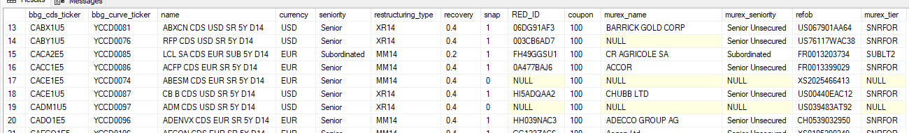
sha2.new_bond_mgmt.bond_details
sha2.new_bond_mgmt.bond_ratings
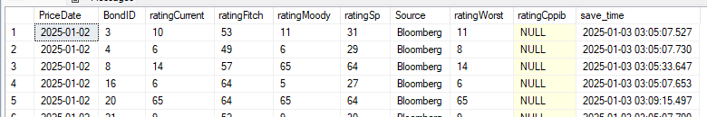
sha2.map.map_rating
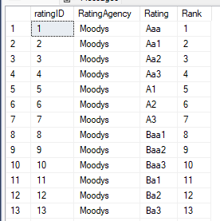
sha2.new_bond_mgmt.bond_secmaster
sha2.new_cds_mgmt.cds_quote
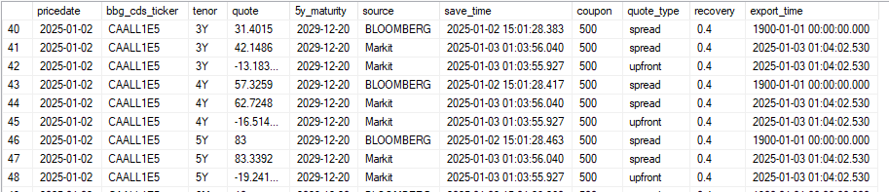
sha2.dbo.LastWorkday (function, not a table)
(finds the last business day)
sha2.barra.full_barra_risk
(bond positons, notionals, cr01 by tenor, dv01 by tenor, PMs)
sha2.new_bond_mgmt.CILibrary_bond_pricing
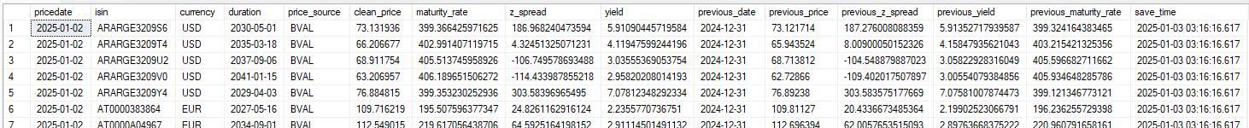
sha2.new_cds_mgmt.markit_tranche_spreads
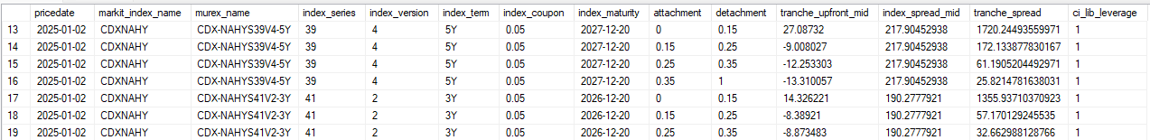
sha2.new_cds_mgmt.cdx_spread
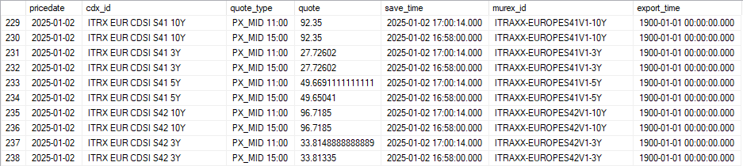
sha2.new_cds_mgmt.cdx_list
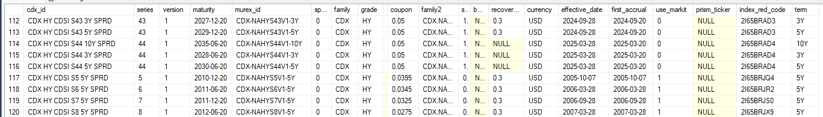
sha2.new_cds_mgmt.cdx_underlyings
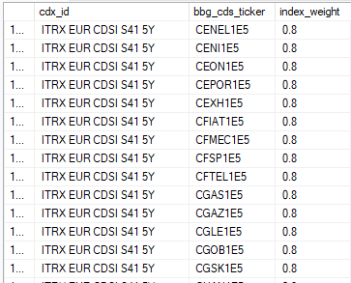
sha2.new_cds_mgmt.cds_defaults
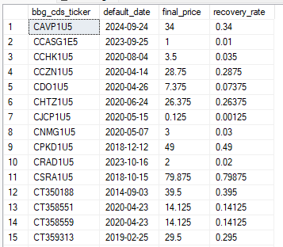
sha2.rates.asset_list
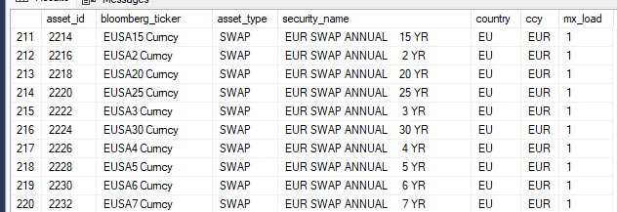
sha2.rates.asset_quotes
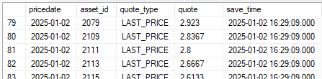
sha2.rates.murex_ir_map
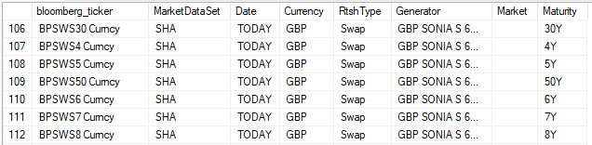
Sha2.rates.asset_quotes + fx
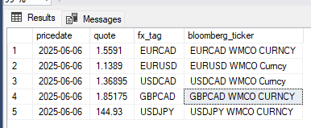

When pitching an investment derivative strategy to a hedge fund, you need to go beyond the core trade idea and focus heavily on operational considerations. Hedge funds are sophisticated counterparties, and their risk committees will look carefully at whether your strategy can be implemented, risk-managed, and scaled. Here are the top operational things to consider:

1. Counterparty & Execution
- Counterparty Selection: Which prime brokers or dealers will facilitate the trades? Do they have balance sheet capacity for your exposures?
- Execution Method: Will the strategy use OTC derivatives, exchange-traded products, or cleared instruments? Execution venues (exchange vs. bilateral) matter for cost and risk.
- Liquidity of Underlying: How liquid are the instruments? Can you get in and out without severe slippage? Are bid-ask spreads manageable?

2. Collateral, Margin & Financing
- Margin Requirements: Initial vs. variation margin. Stress test scenarios—will margin calls be manageable under volatility?
- Collateral Eligibility: Which assets can be posted as collateral? Haircuts? Operational ease of transferring collateral?
- Financing Terms: Repo costs or funding spreads if leverage is used. Does the hedge fund have favorable prime broker financing?

3. Risk Management & Controls
- Counterparty Risk: Is exposure bilateral or centrally cleared? What happens in a default scenario?
- Hedging Liquidity: Can risks (e.g., delta, gamma, vega) be dynamically hedged without excessive cost?
- Concentration Risk: How correlated is the derivative exposure with existing fund positions?
- Operational Limits: Systems in place to monitor Greeks, exposures, and stress tests in real time.

4. Valuation, Pricing & Transparency
- Mark-to-Market: How will the derivatives be valued? Daily pricing feeds, model validation, and independent price verification are critical.
- Complex Payoffs: If exotic, ensure valuation methodologies are robust and transparent. Hedge funds will expect stress-testing.
- Dispute Mechanisms: What happens if counterparties disagree on valuations (e.g., ISDA dispute resolution)?

5. Legal & Documentation
- ISDA Agreements: Ensure Master Agreement and Credit Support Annex (CSA) are in place. Negotiate terms like close-out netting, thresholds, and collateral rules.
- Regulatory Constraints: Consider EMIR, Dodd-Frank, MiFID II reporting requirements.
- Operational Readiness: Trade booking, confirmation, and settlement workflows should be streamlined to avoid breaks.

6. Costs & Fees
- Transaction Costs: Brokerage, clearing fees, exchange fees, margin financing costs.
- Operational Burden: Complexity of trade booking, daily reconciliations, and back-office processing.
- Impact on Performance: Cost drag vs. expected return. Show net returns after operational costs.

7. Scalability & Exit Strategy
- Scalability: Can this strategy be scaled to meaningful size for the hedge fund’s AUM without hitting liquidity or margin constraints?
- Exit Liquidity: In stressed markets, can the fund unwind or roll positions efficiently?
- Roll Risk: For futures or swaps, is there risk in rolling contracts forward (basis risk, funding costs)?

